**Village Savings and Loaning**

The project enhances the financial capabilities of small holder farmers who have little access to financial institutions. The project builds the capacity of beneficiaries to save and to improve their economic capacities. It is also geared toward increasing the household livelihood. The project is implemented in Kisumu, Homabay, Siaya and Vihiga Counties from 2012 and it targets 3360 beneficiaries. The project has so far reached 1117 beneficiaries a cross the 4 counties with capital base of Ksh 5,000,000

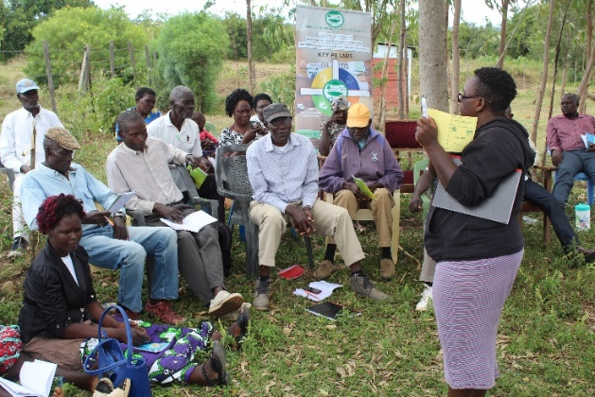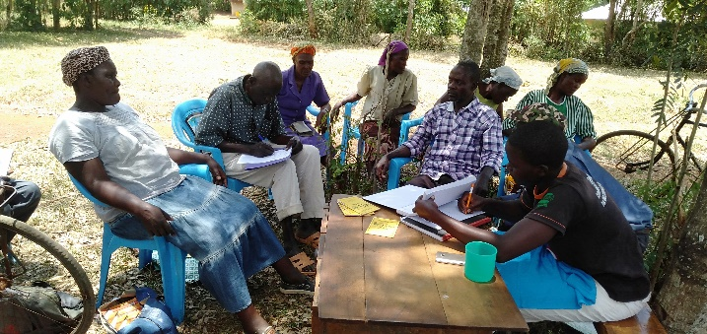

Figure 1 VSL training at the community level

Figure 2 saving process in the communities